

Ellenborough Court

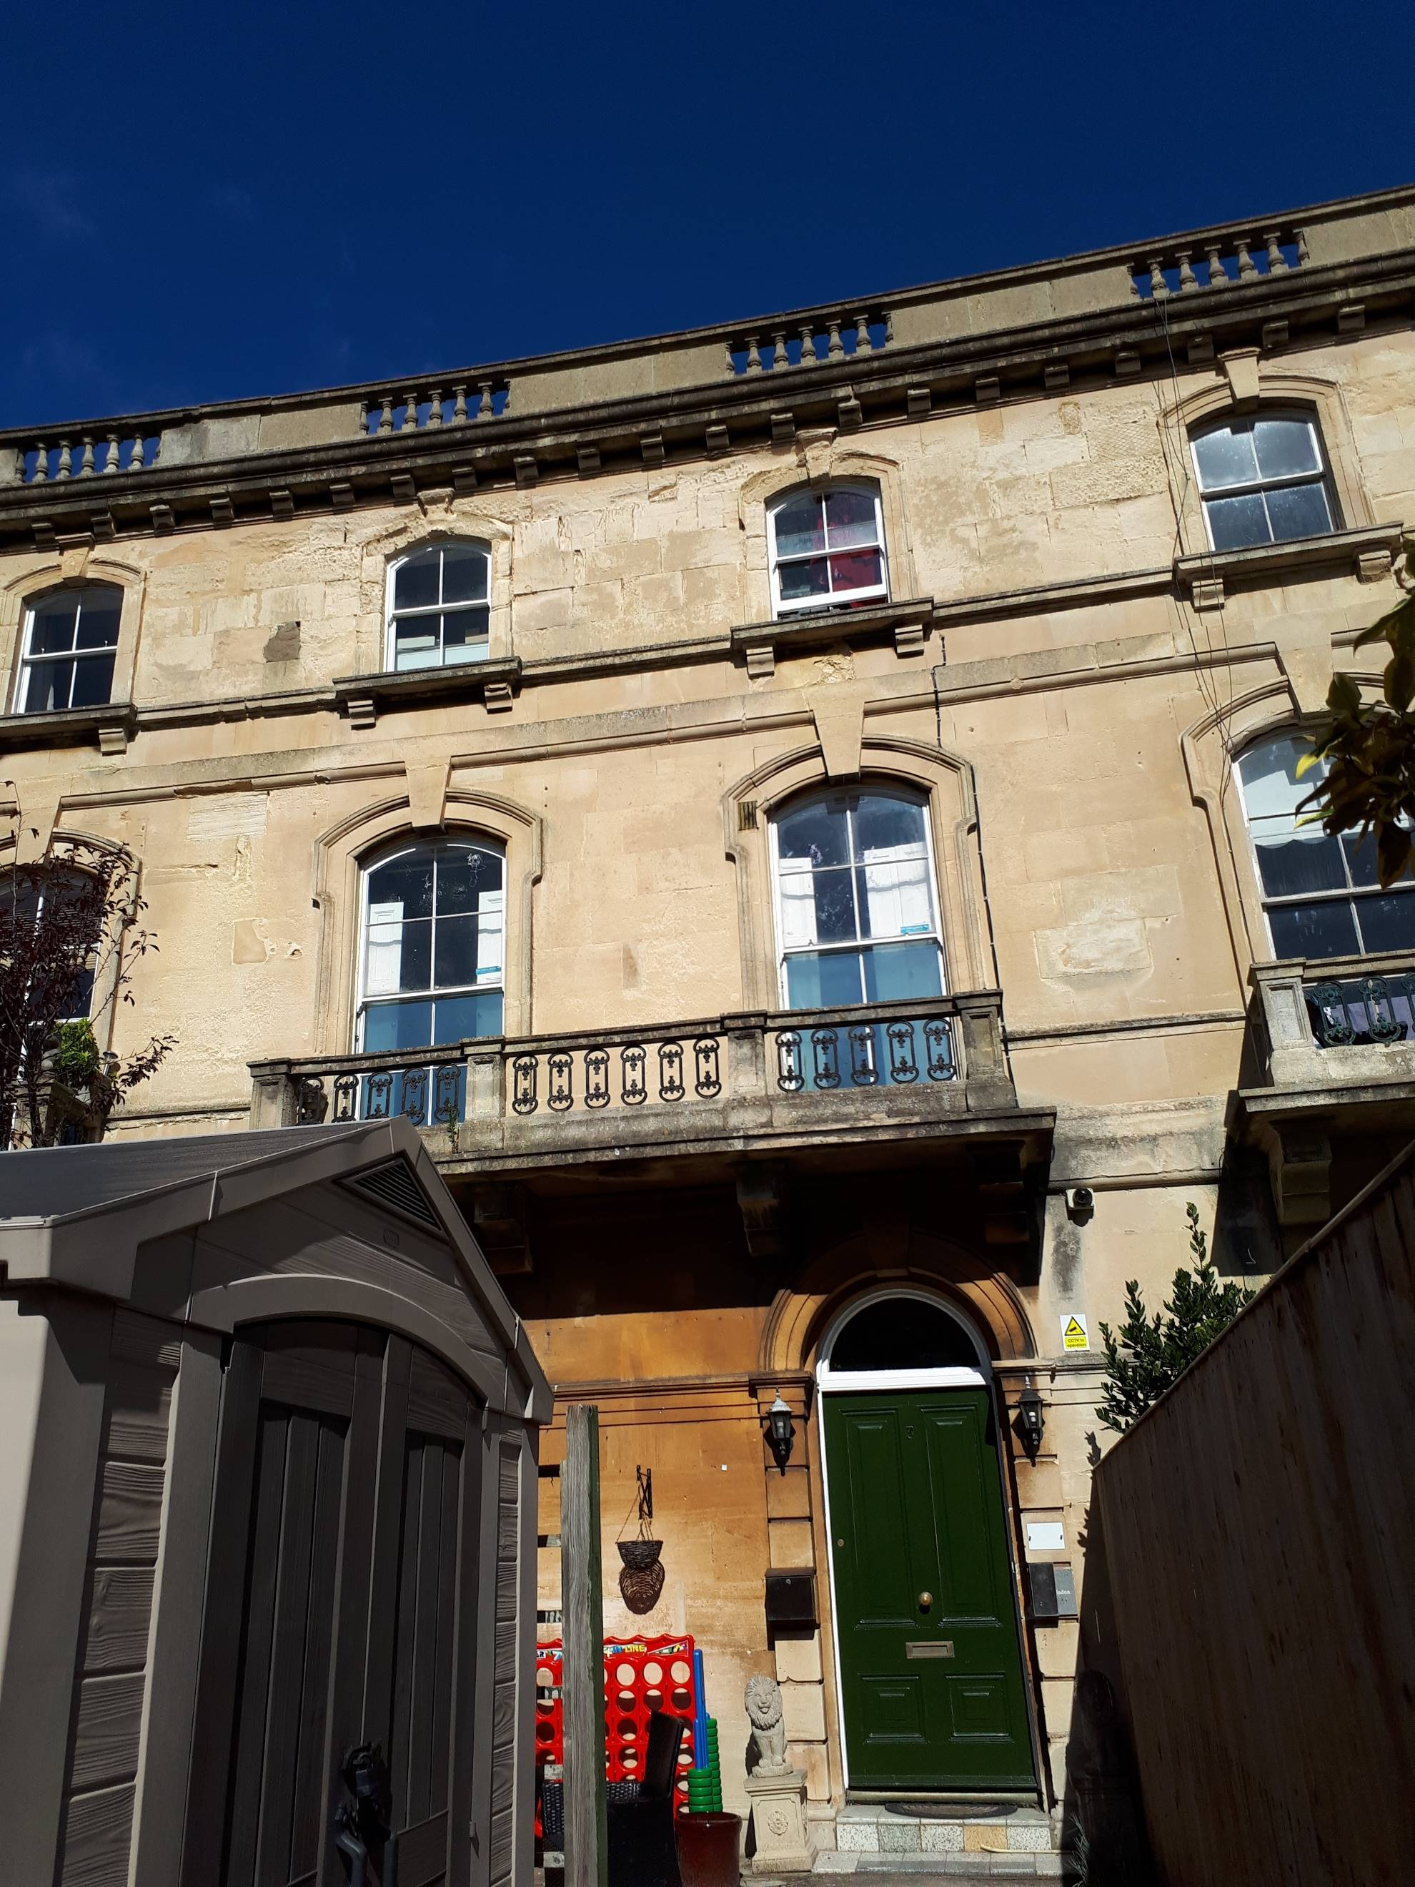





Contents
 | Page
Our Values | 3
About Ellenborough Court | 4
The flats at Ellenborough Court | 5
The staff at Ellenborough Court | 6



About Ellenborough Court

Ellenborough Court is in Weston-Super-Mare
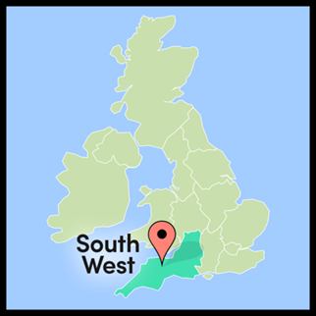

It is close to the Sovereign Shopping Centre and Weston Sea Front.
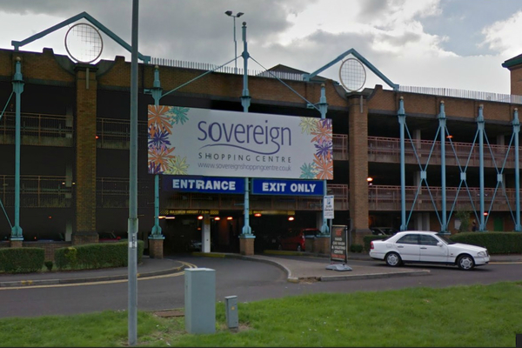
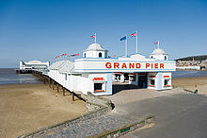

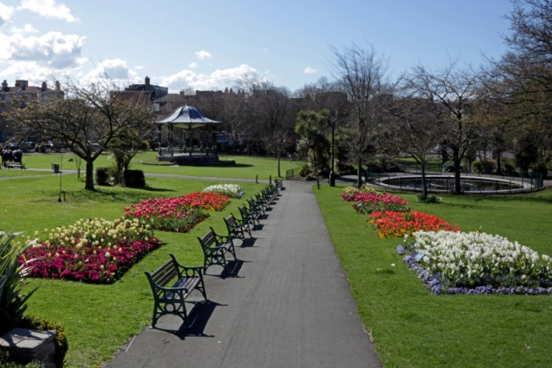




The Flats at Ellenborough Court

Ellenborough Court is a big house with 3 floors.

There are 5 individual flats. Each flat has its own bedroom, lounge, kitchen and bathroom.

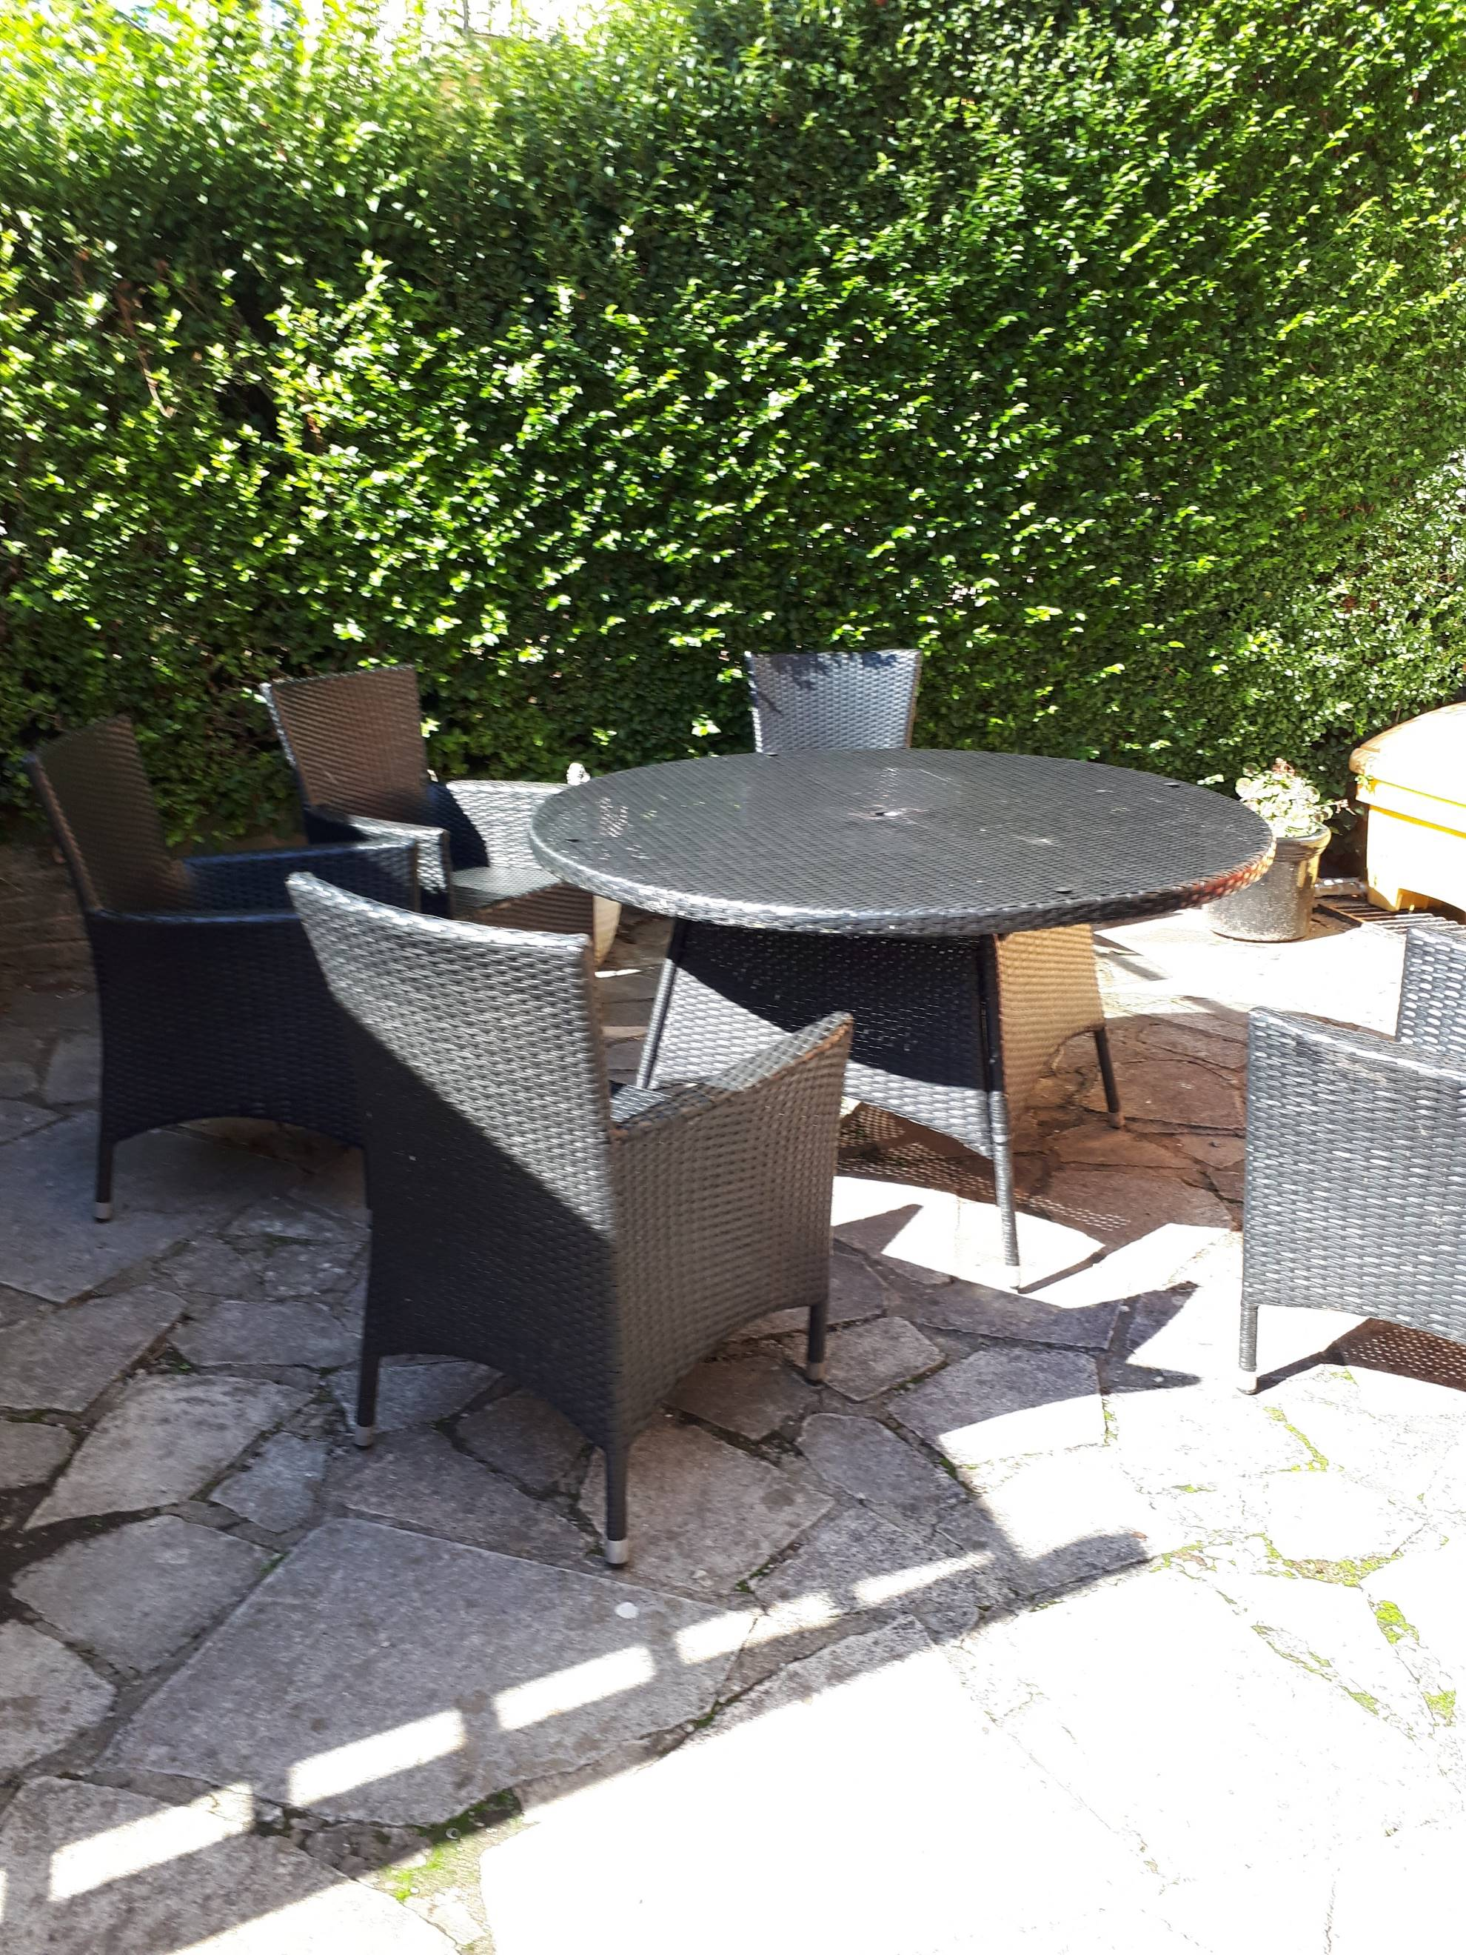

There are shared gardens.

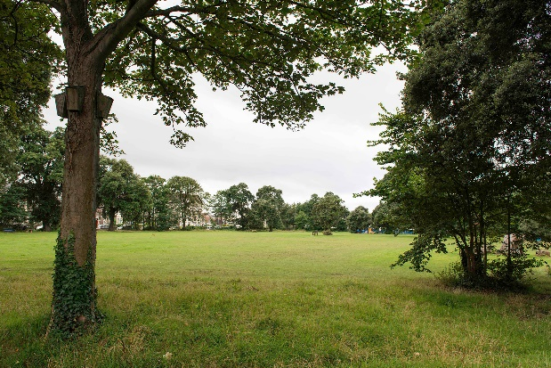

There is a park across the road from Ellenborough Court.


Staff at Ellenborough Court

Rebecca is the Manager at Ellenborough Court


There are staff at Ellenborough Court day and night.

