

Stewart Court

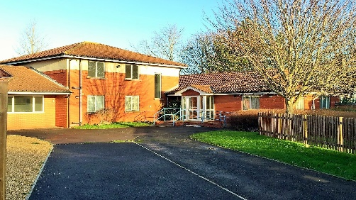





Contents
 | Page
Our Values | 3
About Stewart Court | 4
The houses and flats at Stewart Court | 5
The staff at Stewart Court | 6



About Stewart Court
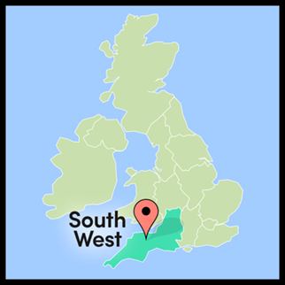
Stewart Court is in Westbury-on-Trym, in North Bristol.
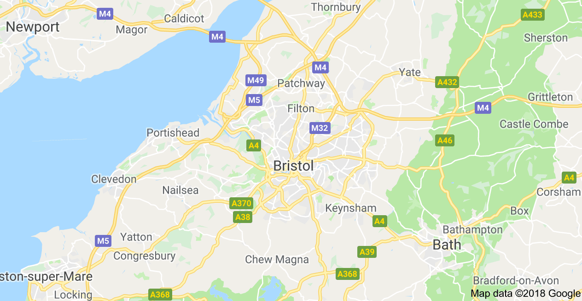

It is close to local shops, The Mall, and Blaise Castle
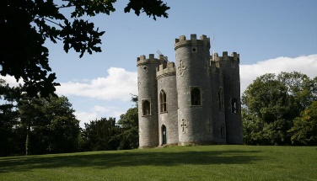


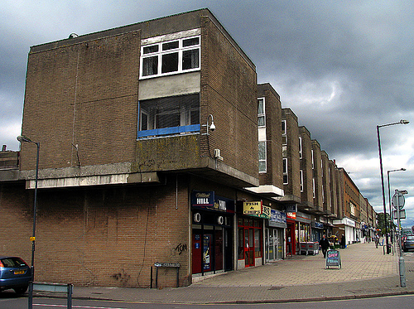

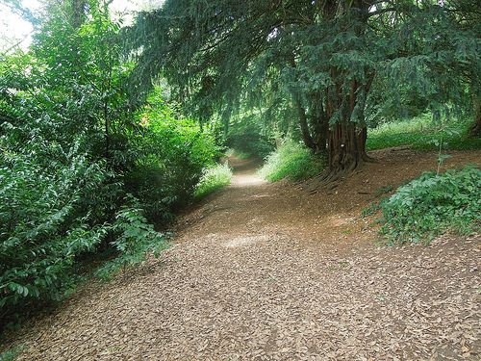
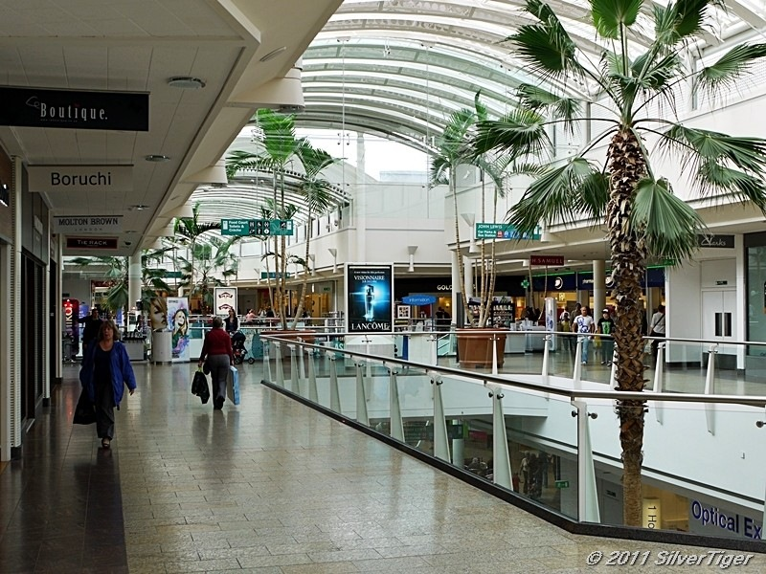

There are 3 houses at Stewart Court.

House 1 and House 3 each have 3 individual flats.
Each flat has its own bedroom, bathroom, kitchen, lounge and garden.
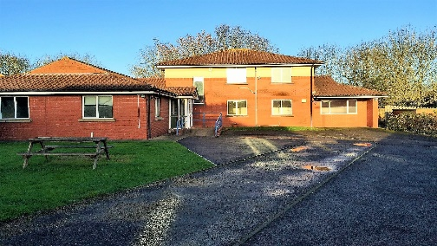
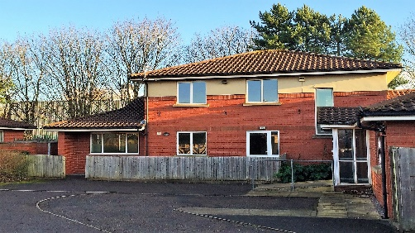

House 2 has a flat upstairs. Downstairs there are 3 bedrooms, each with its own bathroom. The lounge, dining room and kitchen are shared. House 2 has a big, shared garden.
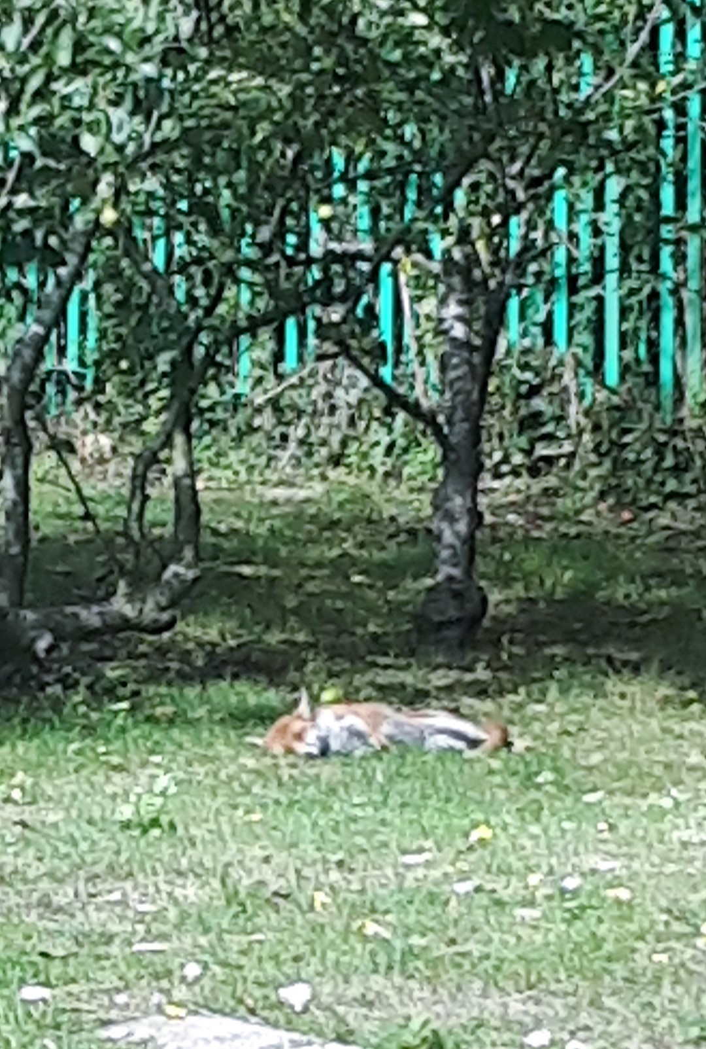

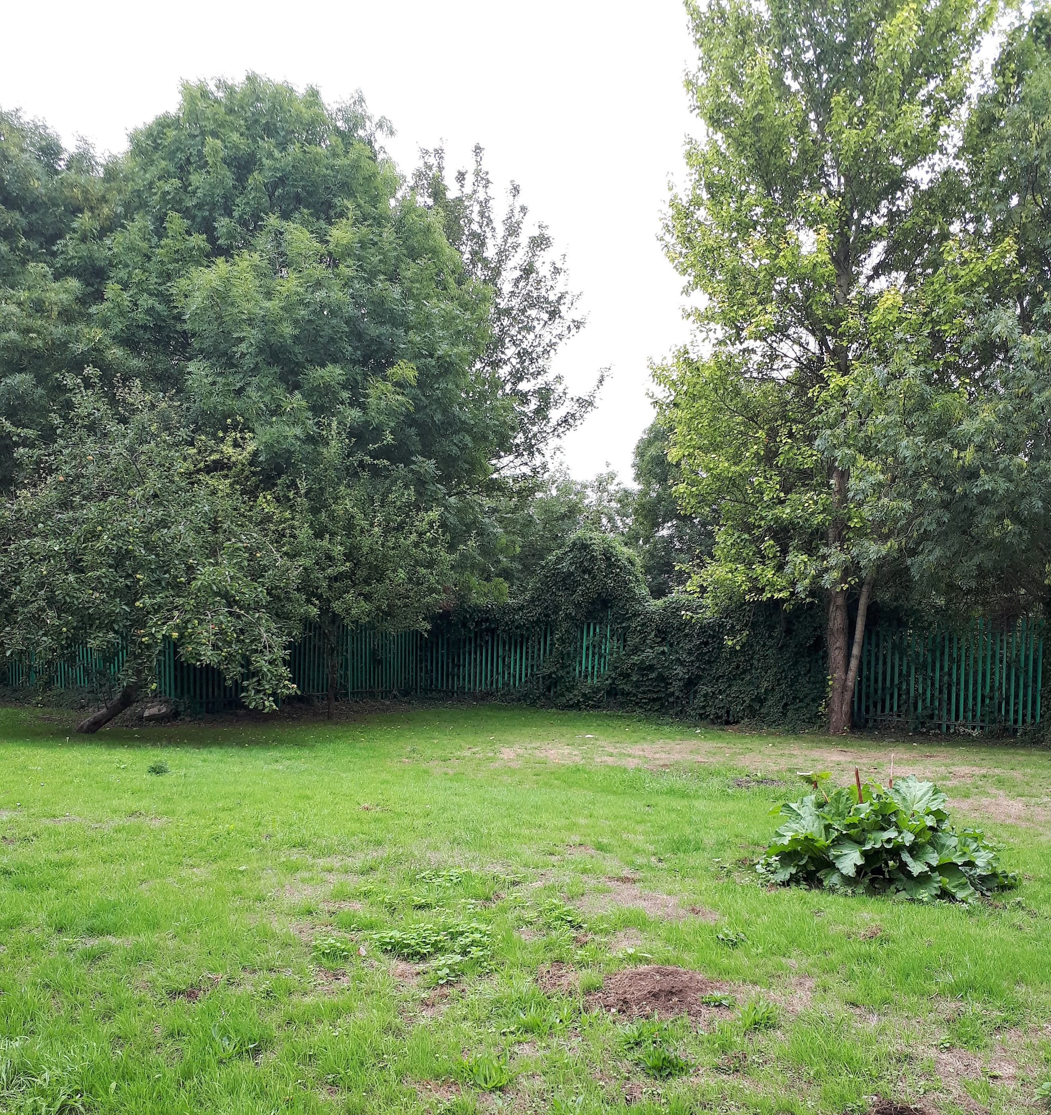


Staff at Stewart Court



Catherine is the Registered Manager at Stewart Court

There are staff at Stewart Court day and night.

