**CTS Longton Court**

**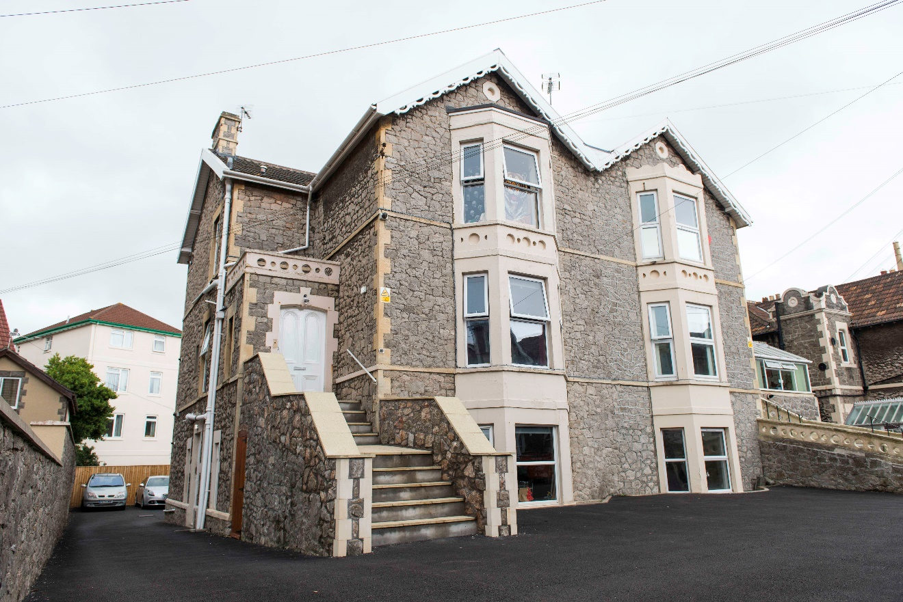**

**Information Guide for People who may use the service**

Longton Court

**Registered Provider**

Community Therapeutic Services

81 High Street

Worle

Weston-super-Mare

North Somerset

BS22 6ET

01934 708772

8, 8a and 10Longton Grove Road

Weston-super-Mare

BS23 1LT

01934 708771

**Summary of Information Guide**

This book is about what you can expect if you come to live at Longton Court.

It will give information about the company that provides your care and the aims of the service.

It will give information about how we can support you with concerns or problems.

It will tell you more about the staff team.

It will inform you about the terms and conditions of having your care provided.

It will give information about how to make a complaint.

You will be provided with important contact details, including the Care Quality Commission who regulate our services.

**Who are we and what do we think?**







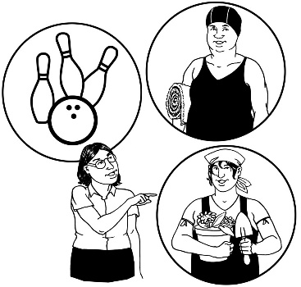

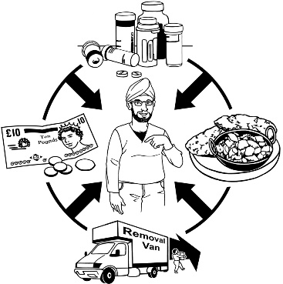

* CTS provide care for people with learning disabilities, mental health needs and complex needs
* We think you should have the same rights as everyone else
* You should be safe and protected from harm
* You should be able to take positive risks and have choices and should be supported to live as independently as you can
* You should be included in every decision about your life and care and should design your own service



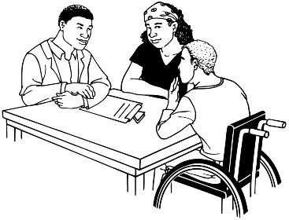



* You should have support to keep in contact with family and friends
* You should have regular reviews and be able to say how we are doing as a provider













**The Aim of CTS**

* To help you be happy and empowered
* To help you learn to take care of yourself
* To help keep you safe and out of trouble
* To help you make friends
* To support you to make safe choices and decisions
* To support you to be part of the local community



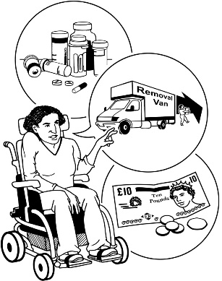



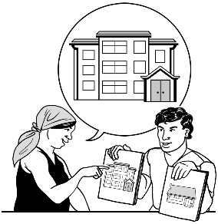

YES

YES



YES

**Before Moving In**

* You are referred by professionals or family
* You will be assessed by our staff who will ask you what you want and need. You can ask questions and find out about the service. We will provide photos and information about the house and location.
* After assessment, we may all agree it is the right place at the right time. If so, you will be offered a placement.



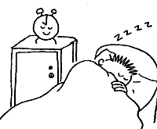

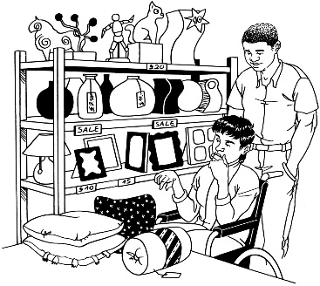

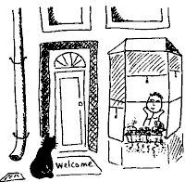

**Transition into Longton Court**

* You get a chance to meet other people who may live in the service and also the staff who will support you.
* You can stay overnight
* You can choose your furniture and how to decorate your room
* You can move in

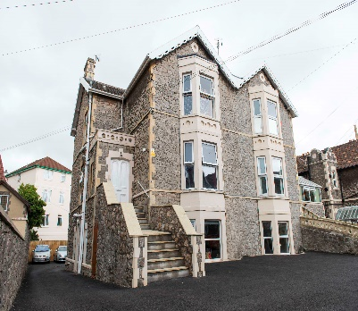

[](http://www.bing.com/images/search?q=weston-super-mare+town+centre&view=detailv2&&&id=F678EF1A03E0C591CEEABE0EDD4DEB4744FAED76&selectedIndex=0&ccid=nMrWJ31x&simid=608031618643136365&thid=JN.lJhmod/ibHn6SNOH9z34Fw)

[](http://www.bing.com/images/search?q=ellenborough+park+weston+super+mare&view=detailv2&&&id=5CDDE3EF8EABEC90D2CFAA37F0FAF569FD3DBE44&selectedIndex=6&ccid=6sDT19yC&simid=608028801147339514&thid=JN.mW%2baMHGltL1rVdwZE3eL1g)

[](http://www.bing.com/images/search?q=ellenborough+park+weston+super+mare&view=detailv2&&&id=2009809973BF9272B94EC0AA538C53286F5C7DAE&selectedIndex=106&ccid=QrSYOare&simid=608015246217841724&thid=JN.WqrdPjq8UV3GxYUkopzXqA)

[](http://www.bing.com/images/search?q=easy+map+of+weston-super-mare+on+uk+map&view=detailv2&&&id=767244A4A9CE99178BEF6D8D3FAB1DC188B1BD35&selectedIndex=82&ccid=M6IbSt58&simid=608051676128544447&thid=JN.dbzXIlzXMABNKbaR2QrQng)

**Longton Court – the house and** **location:**

* Longton Court is a two storey property with 3 spacious bedrooms and 4 separate self-contained flats, and a staff office
* It is in the heart of Weston-super-Mare and very close to the sea-front
* Weston-super-Mare is in North Somerset, in the South-West of England

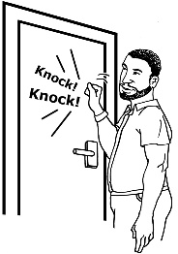



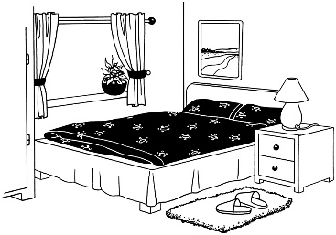

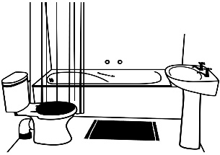

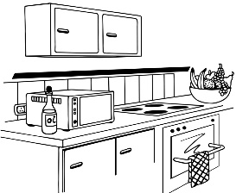

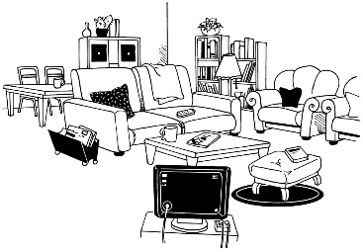



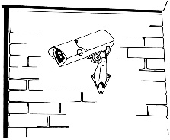

**The Space you live in**

* All the bedrooms and flats are very private and can be decorated to your choice
* The flats and bedrooms are all spacious.
* The flats are fitted with bathrooms, kitchens, lounges and double bedrooms that provide private space for you to live in
* There is a large secluded and secure back garden
* There is also a front patio area and a big double garage
* There is CCTV in all communal areas for your security



MCj03329980000[1]



MCj02803000000[1]

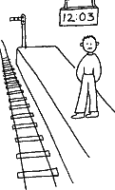





**What do we Provide?**

Help and support with:

* Cooking
* Cleaning
* Community Skills
* Work Skills
* Using public transport
* Budgeting
* Personal hygiene

MCPE03669_0000[1]









* We are there to help you develop good relationships with family
* Help you make positive risks and choices
* Help you to speak up for your rights
* Help you feel secure and important
* Help you engage in activities of your choice









MCj02371720000[1]

MCj02864700000[1]

MCDD00929_0000[1]

**At home we might:**

* Cook
* Draw
* Have Talk Time
* Have time out
* Listen to music
* Watch TV
* Play Games

MMj03546690000[1]



MCj02924820000[1]

MMj02867230000[1]

MCj03328760000[1]







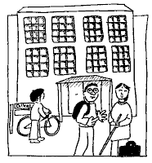

**In the Community we might do the following depending on your choice:**

* Walking
* Trips in car or bus or train
* Bowling
* Gym
* Swimming
* Cycling
* Go to the Pub or to a Social Club
* Cinema/Theatre
* College/Work or Voluntary Work



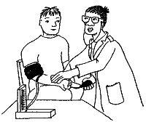

MCj04041990000[1]

MCj02505750000[1]

MCj03382400000[1]





**We can support your health needs by:**

* Helping you take your medication
* Supporting you to visit the Doctor/Nurse or Health Check Clinic
* Supporting you to visit the Dentist
* Chiropodist appointments
* Optician appointments and eye tests
* We encourage healthy eating by helping you shop and cook healthy food
* We encourage you to choose a healthy lifestyle with exercise







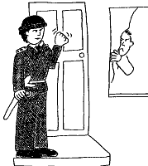



MCHM00418_0000[1]

**What problems can we help with?**

**You might have difficulties with:**

* feeling angry
* feeling depressed or sad
* feeling anxious or nervous or shy
* You might have been in trouble with the Police, in Prison or in Hospital
* You might have been abused or bullied by others
* Or even tried to hurt yourself in the past













MCj00788230000[1]



**House Rules:**

* No Fighting or Physical Abuse
* No Verbal Abuse
* No Breaking the Law
* No Sleeping all day
* No Smoking in the house
* No Breaking Furniture
* No Bullying



**We expect you to:**

* Help around the house
* Respect others
* Try not to be too noisy
* Stick to the rules





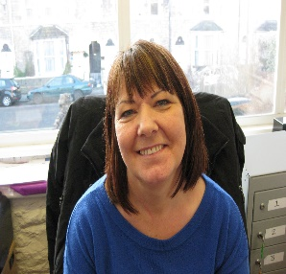

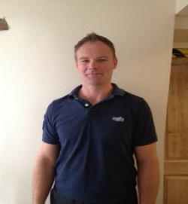

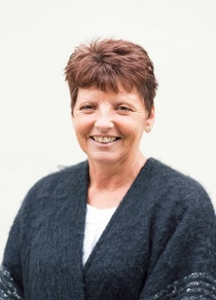



**About The Staff Team**

* This is Emily and she is an owner/director of CTS. She is also a Clinical Psychologist
* This is David. He is an owner/Director of CTS, the Responsible Individual and a Clinical Psychologist. David is also the Registered Manager of Longton Court
* This is Gail, she is the Acting Manager at Longton Court
* This is Marc. He is a Clinical Psychologist
* This is Tracy. Tracy is a Learning Disability Nurse
* We have a very skilled team that can provide support for your needs and help you move towards independence and choice











* We have lots of very caring and skilled staff to help you
* Our staff are trained in working with People with Learning Disability, Mental Health Needs and behaviours described as challenging. They receive regular supervision to ensure they are doing a good job
* Staff help to teach you new skills
* They listen to your goals and support you to be safe in your choices
* You will have a key worker who will listen to your goals and help create a Positive Behaviour Support Plan
* They will help if you have any problems or questions





MCj02924820000[1]



**Money**

* You may have to contribute towards the cost of your care and activities from your Benefits.

This could include:

* Transport
* Activity Entrance Fees / Tickets
* Your social worker may arrange for you to pay a fee towards your care





**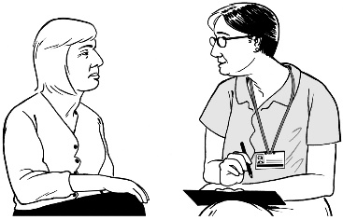**

**Advocacy and Extra Support**

* We will help you to find Advocacy services in your local area. The local Advocacy Service in Weston-Super-Mare, where the office is based is:

People First

Partnership House

Building 400

Worle

BS22 6WA

Tel: 01934 426086

|  |  |
| --- | --- |
|  | [enquiries.nspf@yahoo.co.uk](mailto:enquiries.nspf@yahoo.co.uk?subject=email) |

We have a brochure on what Advocacy is and what services are available for you

* The Local Learning Disability Team can be found at this address:

Castlewood (Post Point 10)  
Tickenham Road  
Clevedon  
BS21 6FW

01934 427600

mailto:

[ctpld@nsomersetcp-cic.nhs.uk](mailto:ctpld@nsomersetcp-cic.nhs.uk)

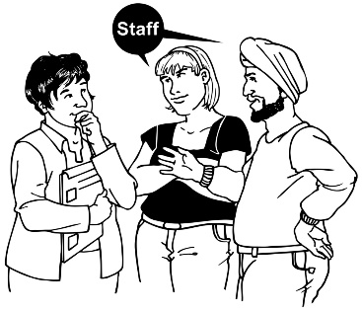











**How do we make sure we deliver Outstanding Quality?**

* We are registered with CQC. They inspect our home regularly to make sure we are doing a good job and we put our reports and ratings clearly in our services
* **We also inspect our own services and do regular audits. Once a year you and your family will be asked for feedback about how we are doing through a satisfaction survey. These are all confidential**
* **We are covered by insurance to carry on our services**

**Making a complaint, comment or compliment about our services:**

* If you are unhappy about something you can make a complaint at any time. We have a complaints policy that will be available in the home from any member of staff. They can also help you to fill in a complaints form if you choose. You may also wish to make a compliment in the same way





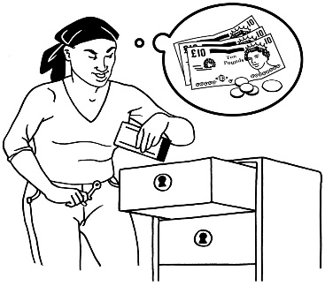

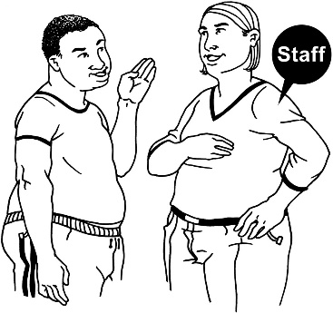



**Safeguarding Adults Policy**

CTS are committed to keeping you safe from:

* Abuse
* Neglect
* Bullying
* We have a clear Safeguarding adults policy that is available in easy read format in every home
* If you or someone you know experiences abuse, please call CARE CONNECT on

01934 888 801

* Please alert a member of staff if you or anyone else is experiencing any form of abuse or neglect

**Important addresses and numbers**



****

****



The CTS Main Office is:

81 High Street

Worle

Weston-super-Mare

North Somerset

BS22 6ET

Tel: 01934 708772

e-mail: [info@cts-homes.co.uk](mailto:info@cts-homes.co.uk)

website: [www.cts-homes.co.uk](http://www.cts-homes.co.uk)

**CQC Office**

Care Quality Commission

National Correspondence

Citygate

Gallowgate

Newcastle-upon-Tyne

NE1 4PA

Tel: 03000 616161





**Additional Information**

* This information can be provided in other languages and formats upon request such as large print, audio cassette and CD Rom.
* Please contact the CTS office for further information.
* I hope this has been helpful

Thank you