

Longton Court

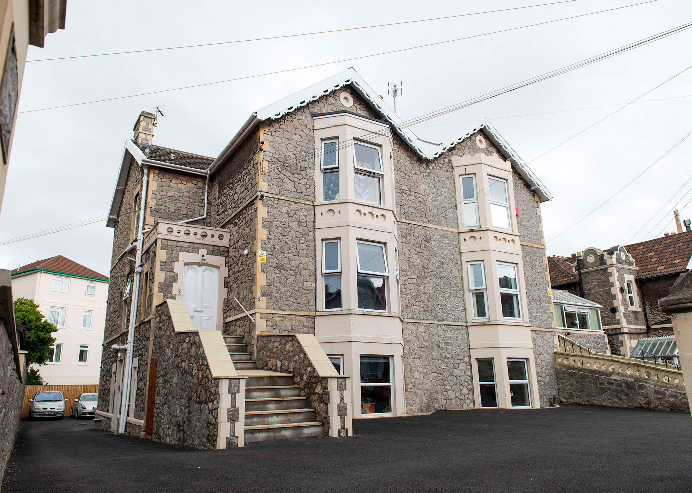





Contents
 | Page
Our Values | 3
About Longton Court | 4
The house and flats at Longton Court | 5
The staff at Longton Court | 6

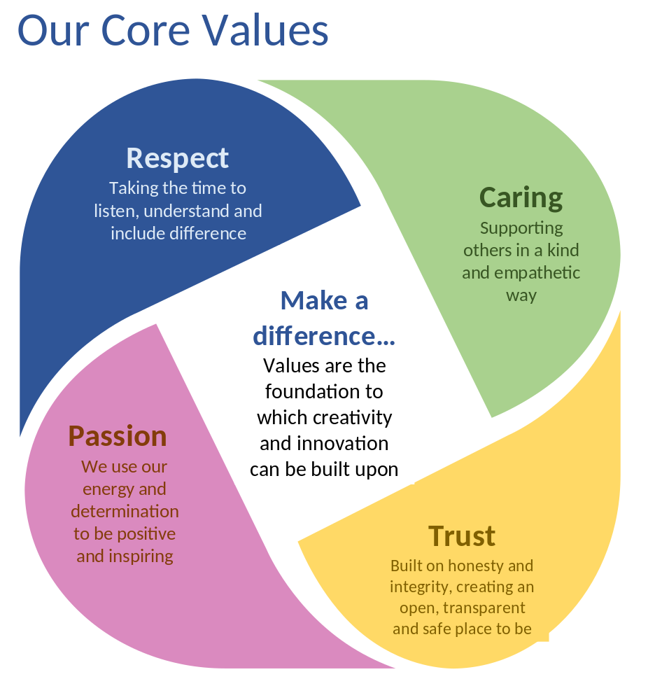

About Longton Court

Longton Court is in Weston-Super-Mare
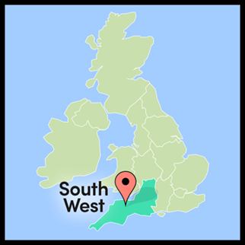
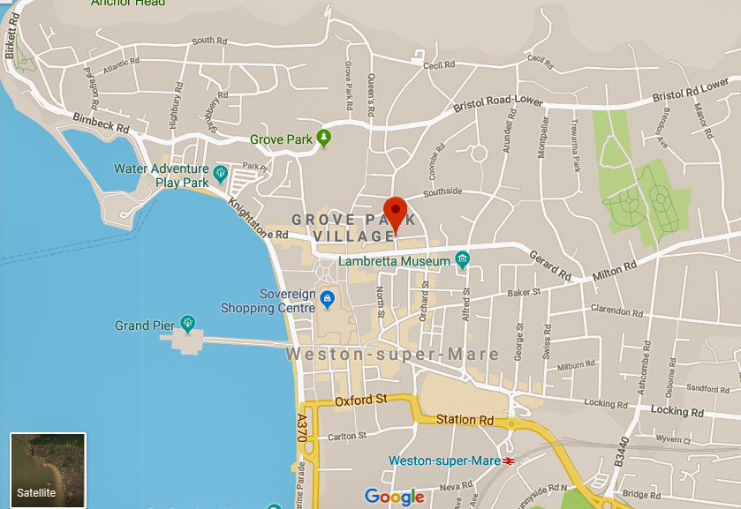

It is close to the Sovereign Shopping Centre, Weston Sea Front and a park.
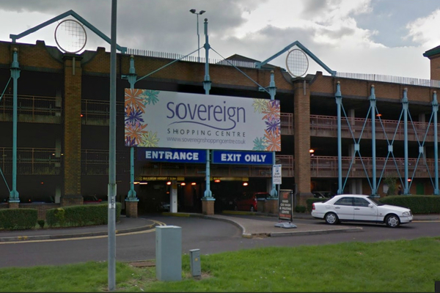
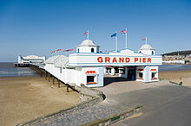

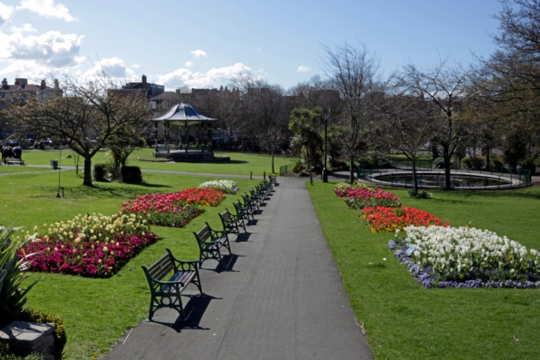

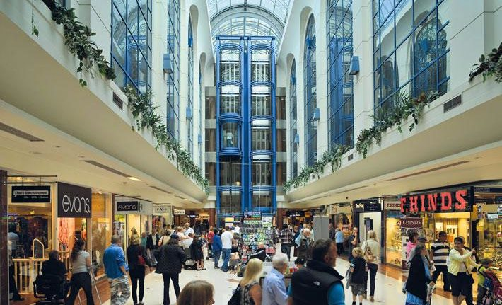
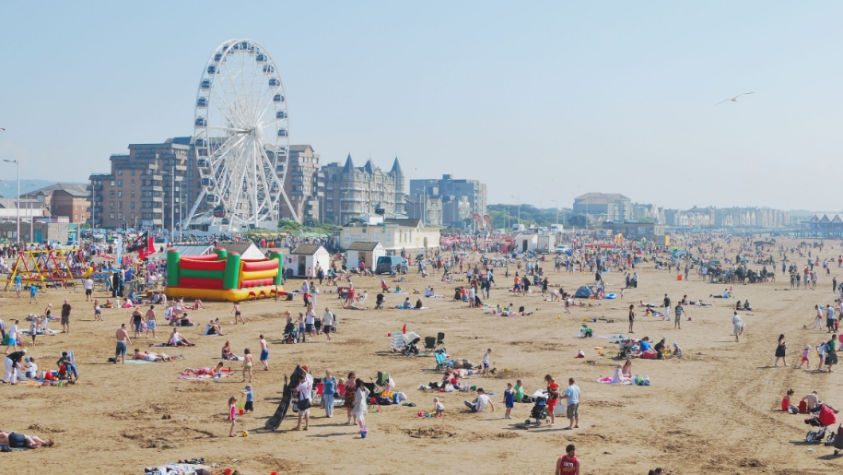

The House and flats Longton Court

Longton Court is a big house with 3 floors.

There are 4 individual flats. Each flat has its own bedroom, lounge, kitchen and bathroom.

In the main house, there are 3 big bedrooms, each with an en-suite bathroom.

There is a shared lounge, kitchen and dining room.
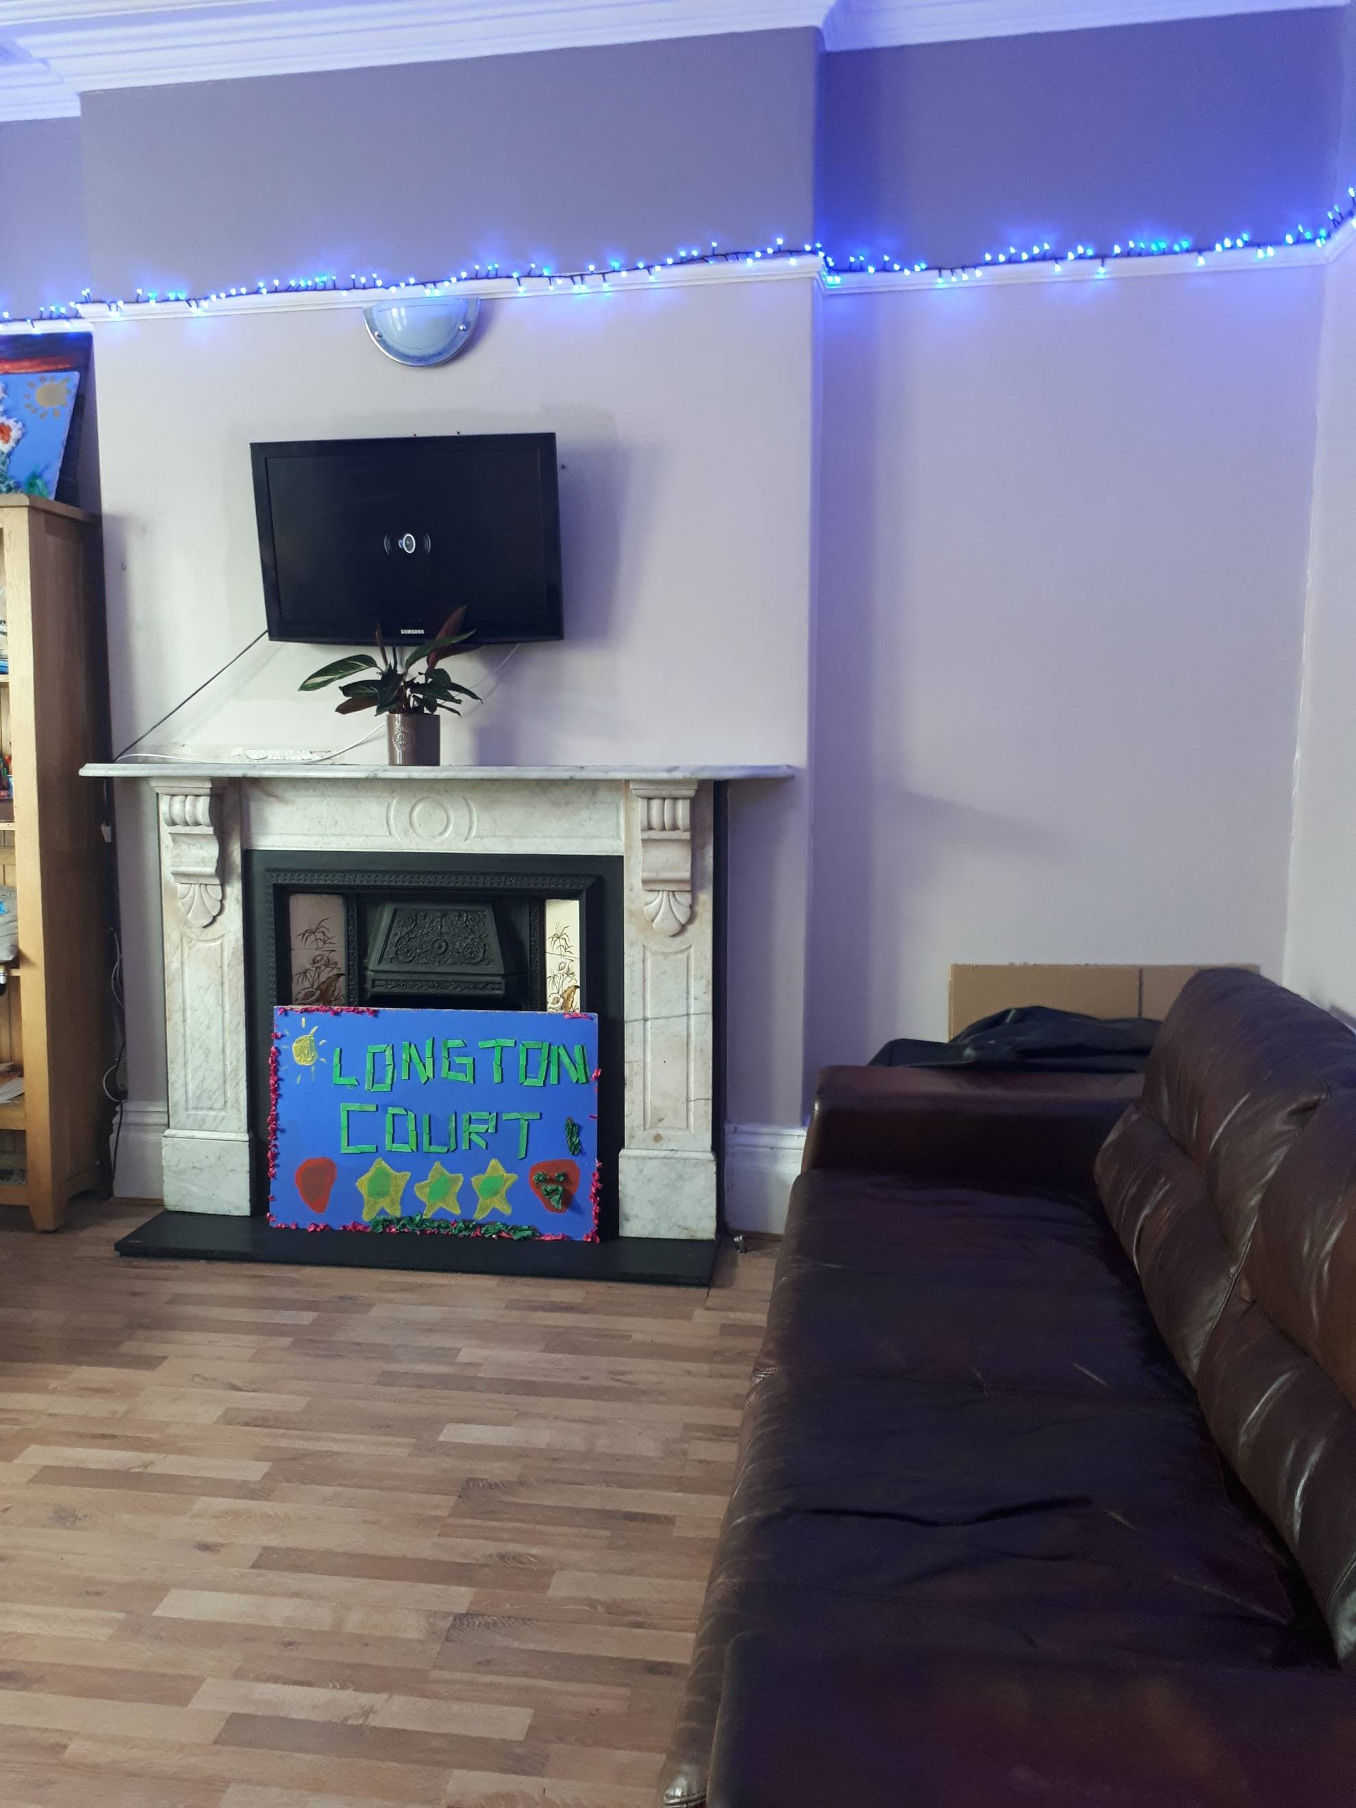
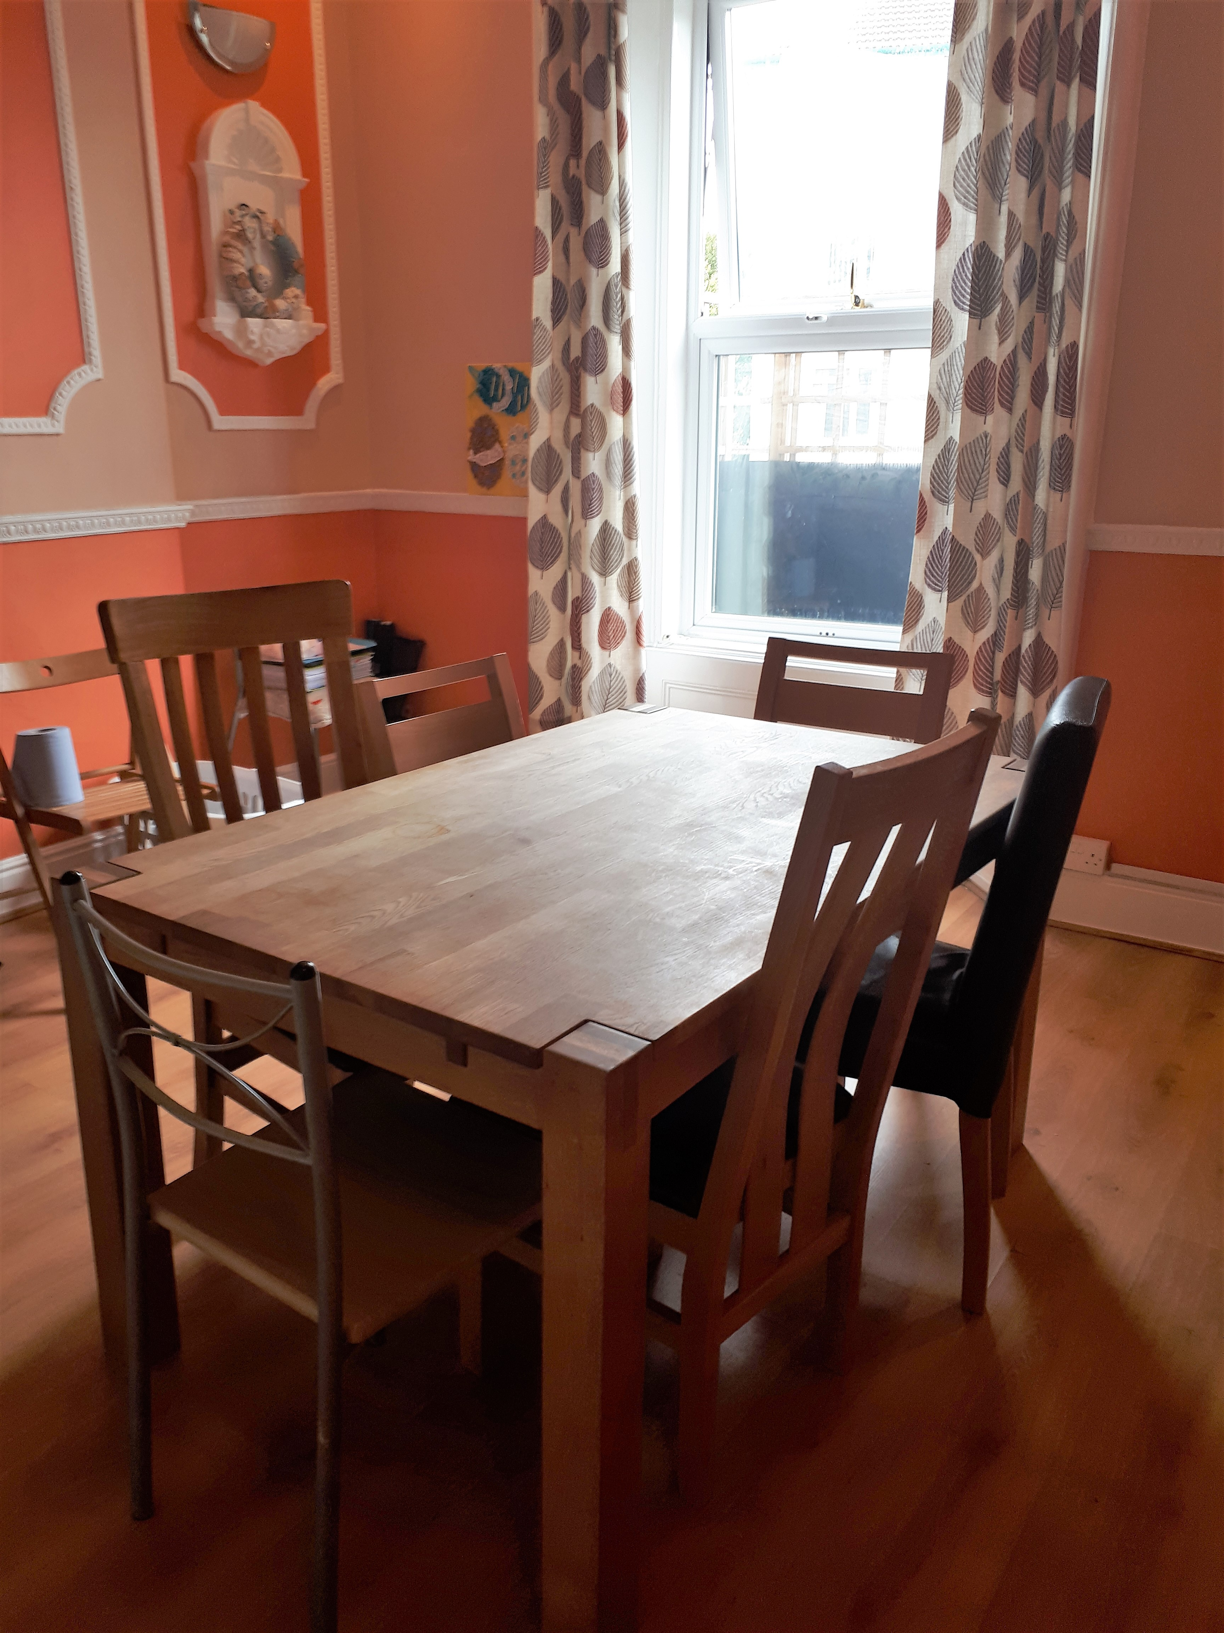

There is a big back garden, with an arts and crafts room.
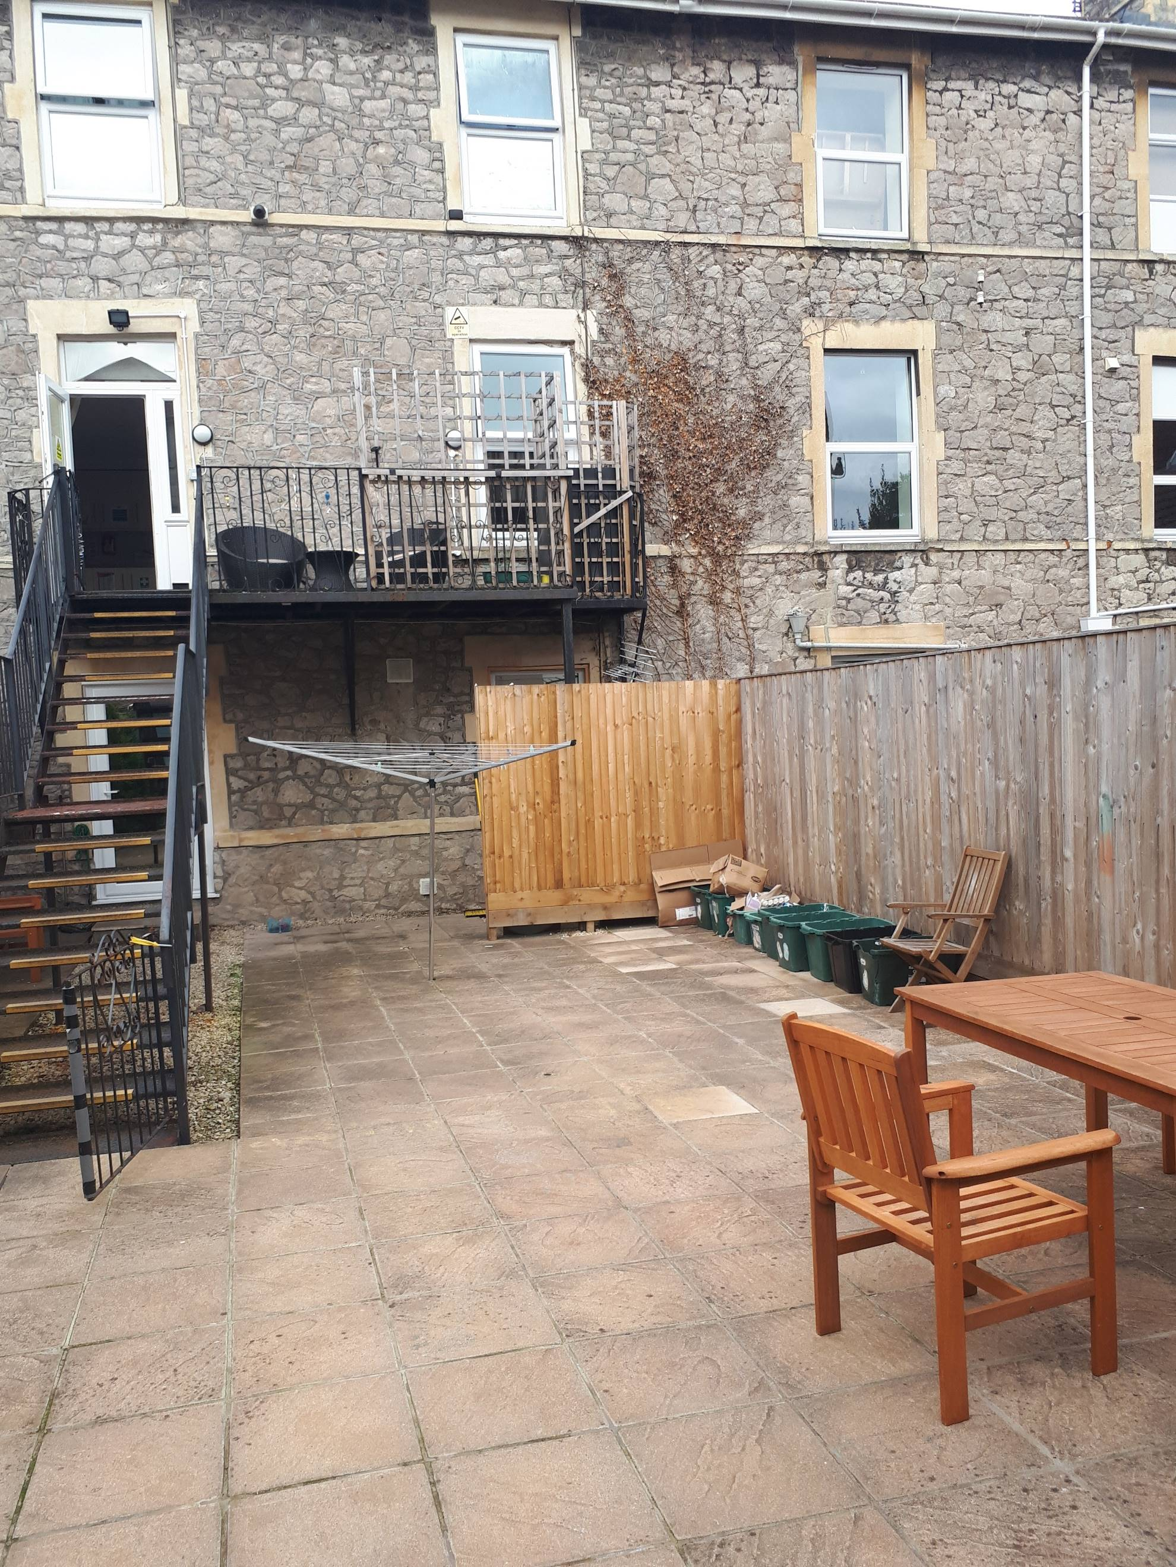
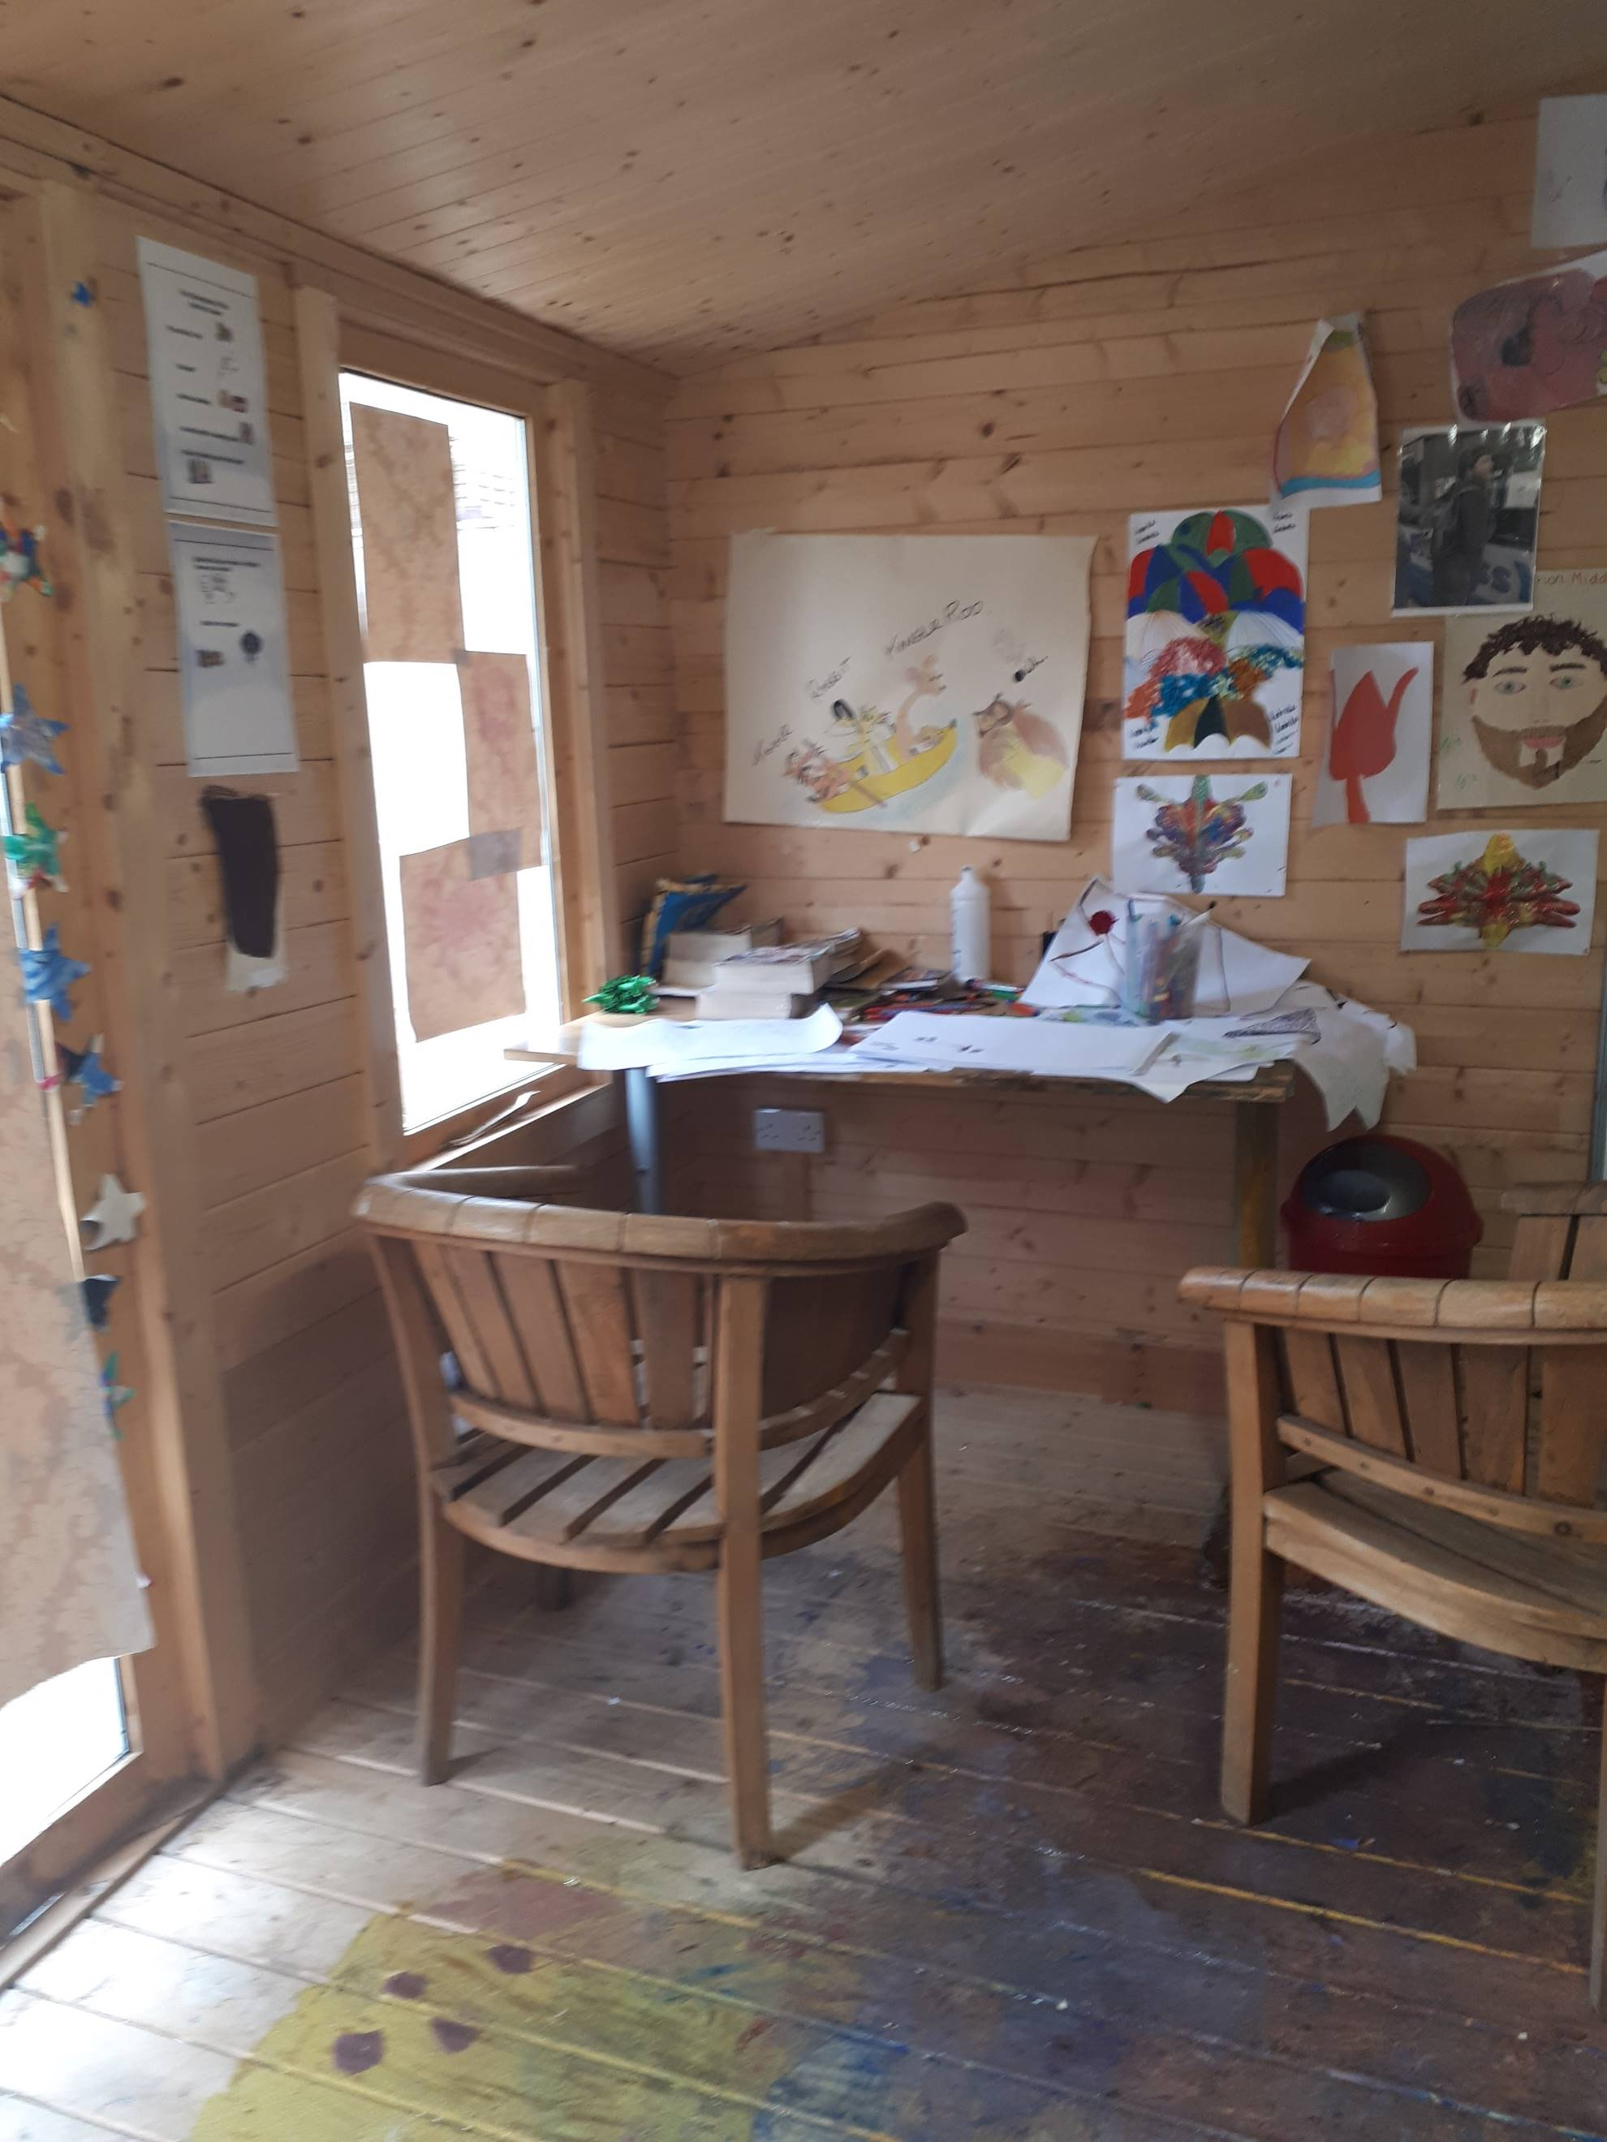


Staff at Longton Court



Emily is the Registered Manager at Longton Court

There are staff at Longton Court day and night.

