

Bridgwater Court

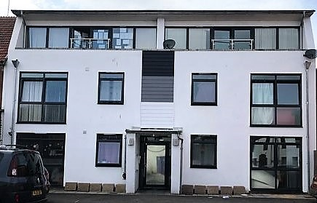





Contents
 | Page
Our Values | 3
About Bridgwater Court | 4
The flats at Bridgwater Court | 5
The staff at Bridgwater Court | 6

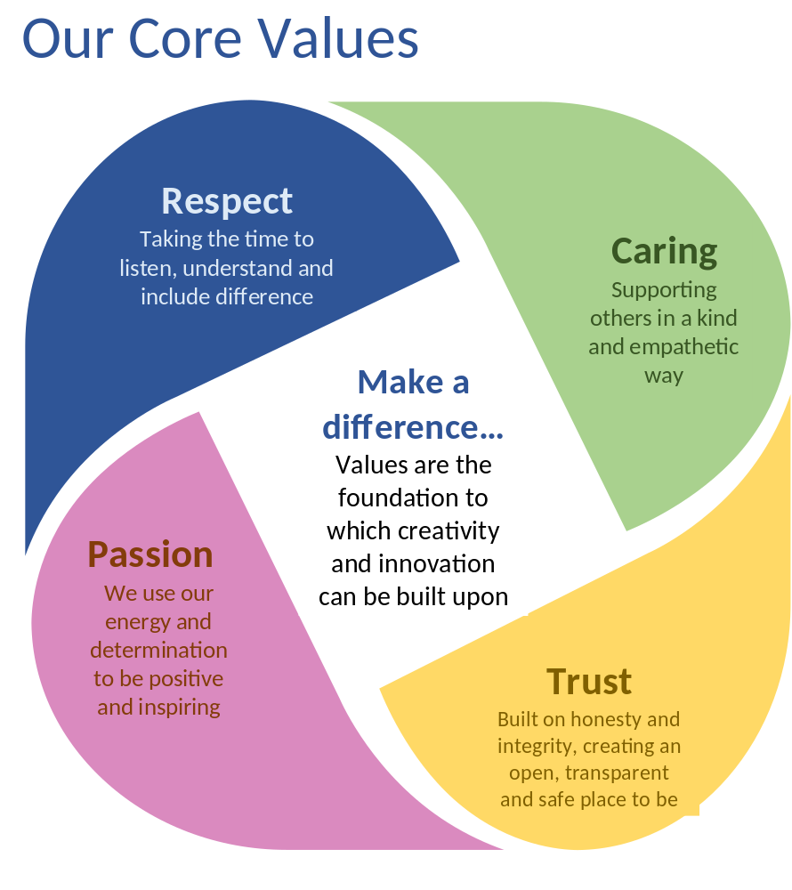

About Bridgwater Court

Bridgwater Court is Bridgwater, Somerset.
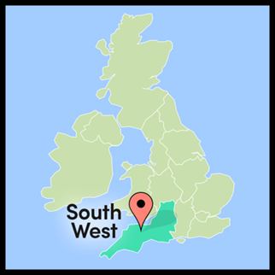
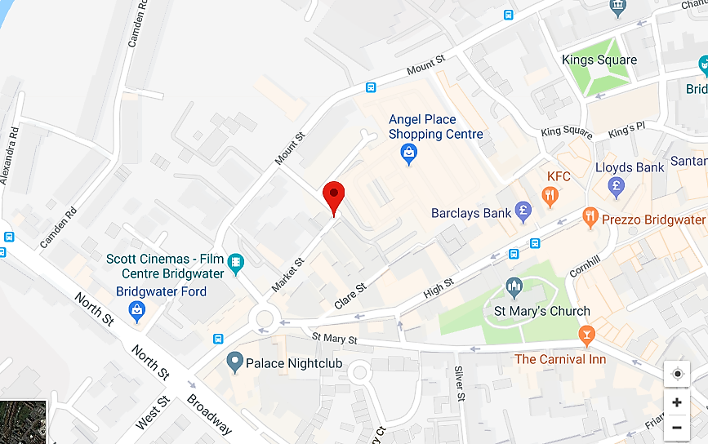

It is close to the Angel Shopping Centre and the cinema.
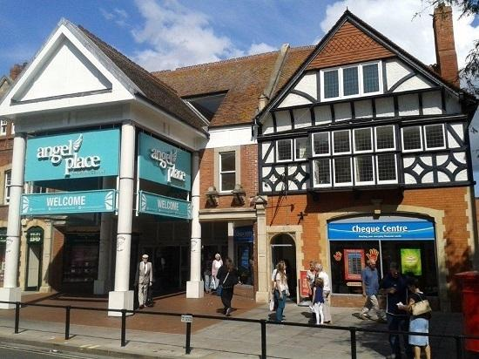
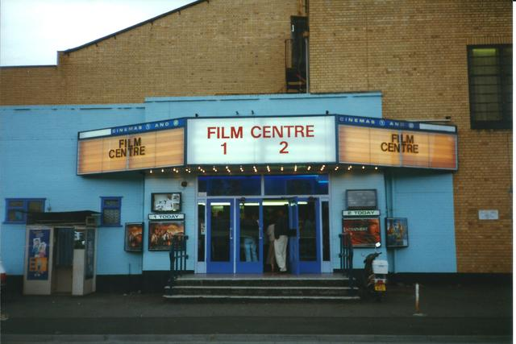

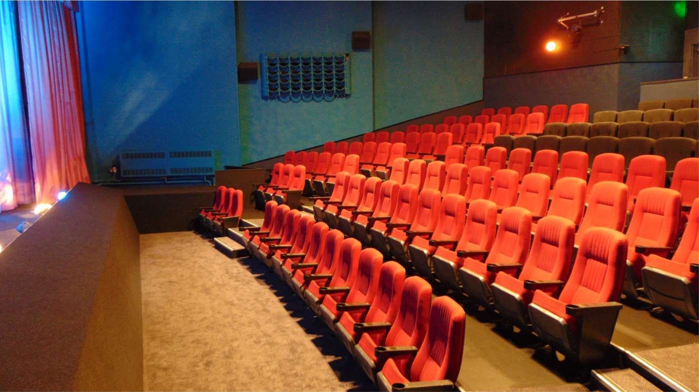
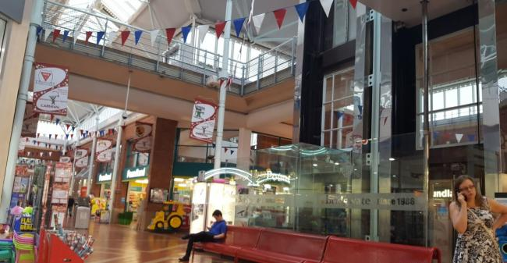

The House and flats Bridgwater Court

Bridgwater Court is a small block of flats

There are 9 individual flats. Each flat has its own bedroom, lounge, kitchen and bathroom.

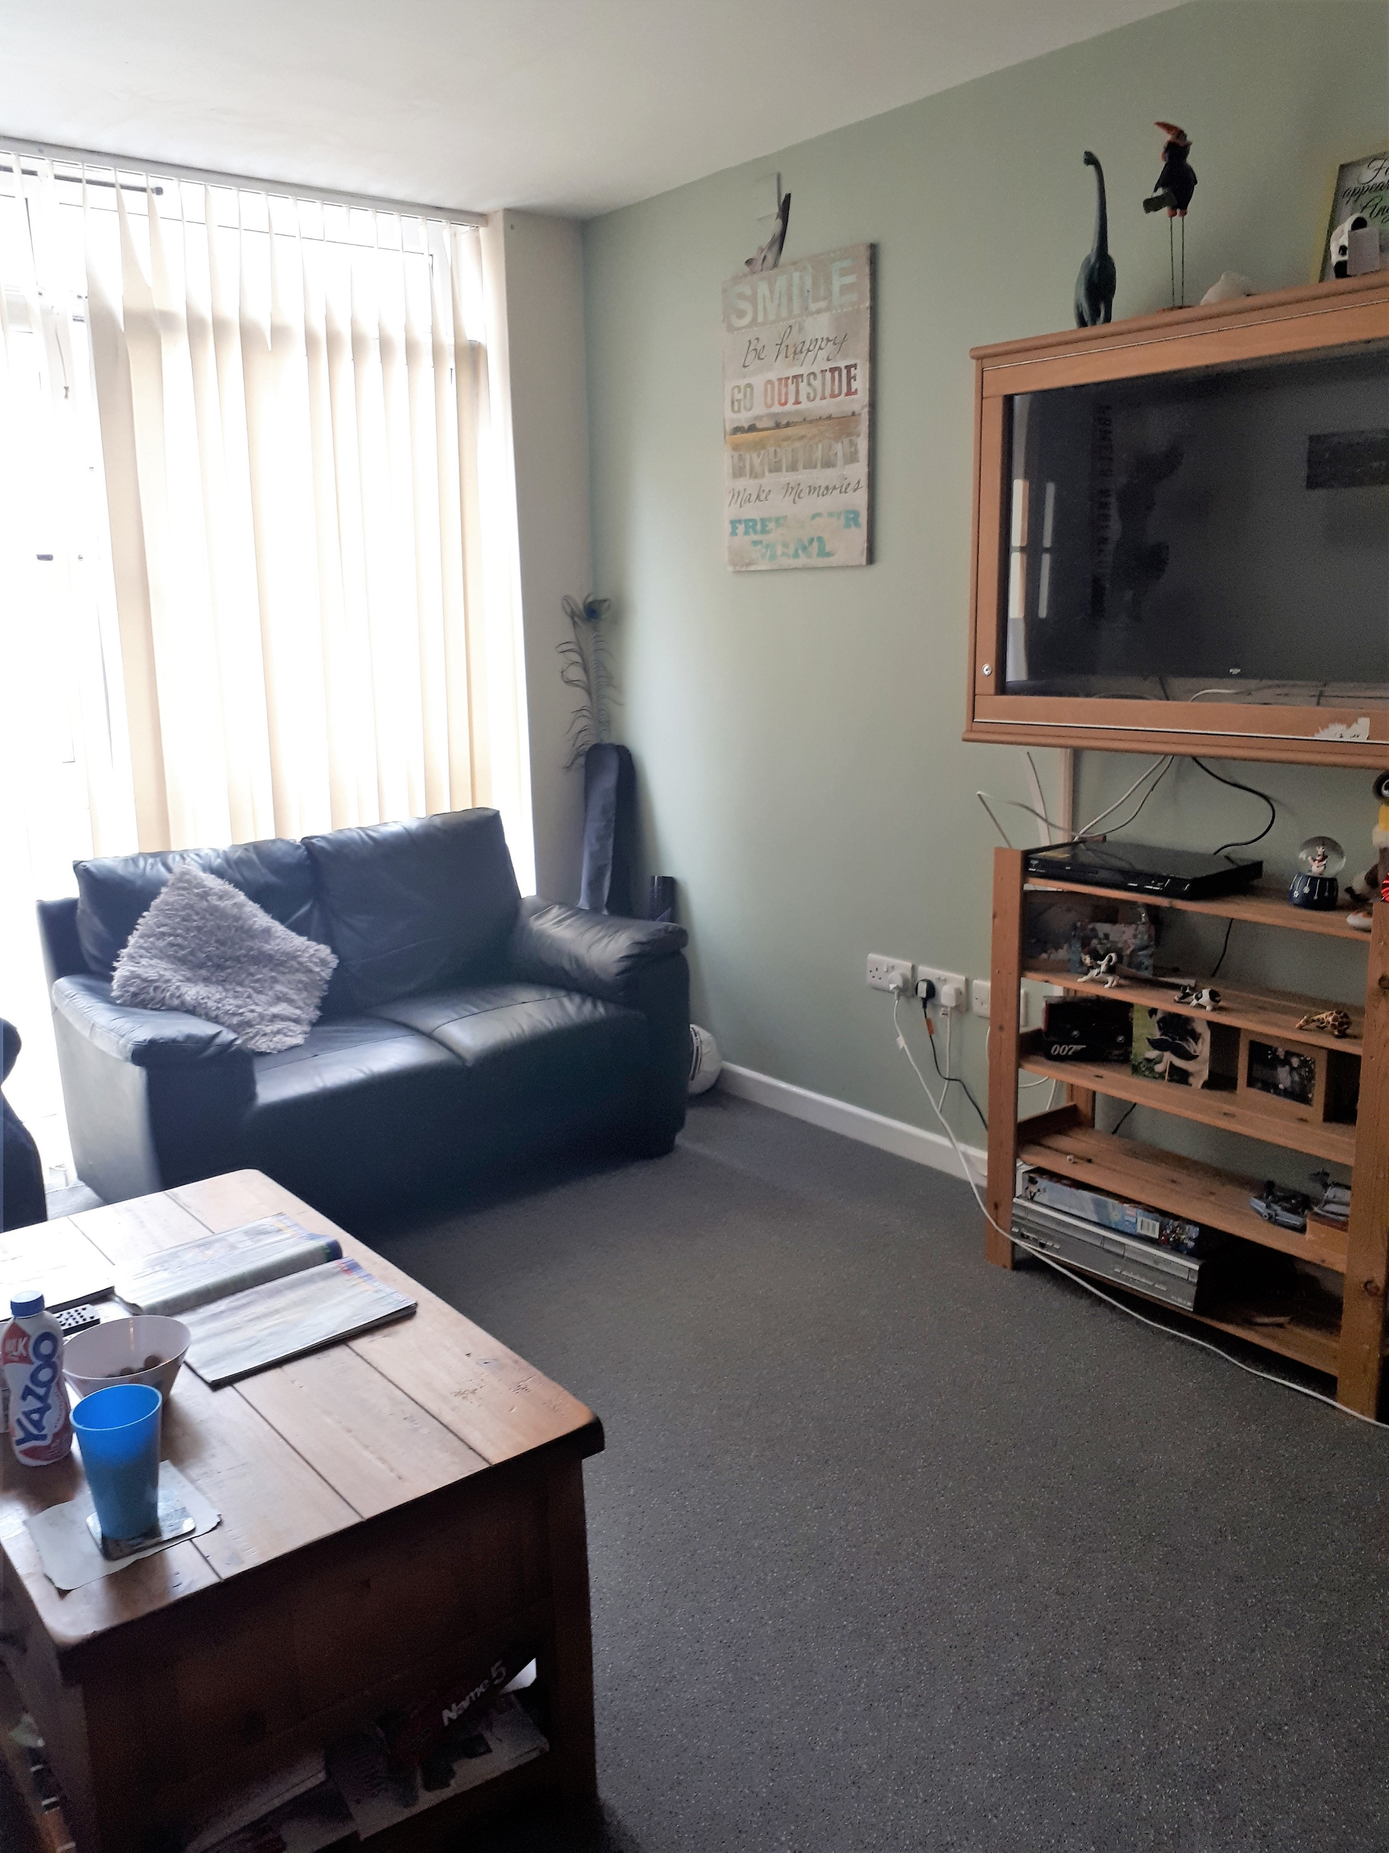
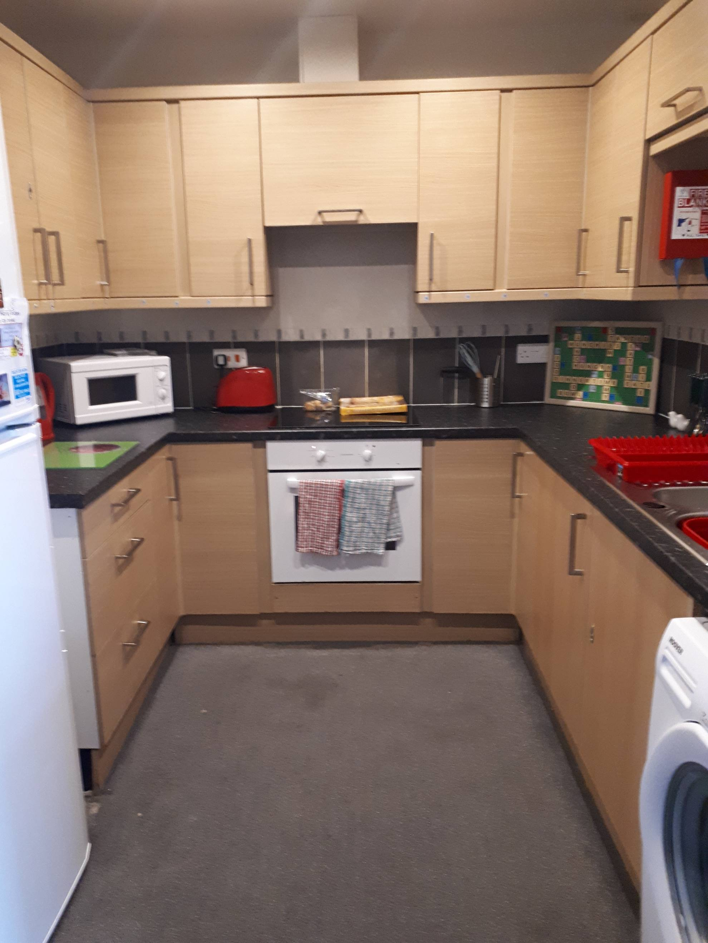

There is also a staff office.


Staff at Bridgwater Court



Becky is the Registered Manager at
Bridgwater Court

There are staff at Bridgwater Court day and night.

